A
Case Report
on
PROCESS PLANNING FOR A MANUFACTURED COMPONENT
Submitted by
Chavan Deepak Balu
Under the Guidance of
Prof. Y.L. Suryavanshi
In partial fulfilment of
B.Tech. in
(Electronics & Telecommunications Engineering)
DR. BABASAHEB AMBEDKAR TECHNOLOGICAL UNIVERSITY,
LONERE (M.S.)

Marathwada Shikshan Prasarak Mandal’s
Deogiri Institute of Engineering & Management Studies,
Chhatrapati Sambhajinagar.
Department of Electronics & Telecommunications Engineering,
Maharashtra, India.
2026-27

CONTENTS
SR.NO. | TOPIC | PAGE NO.
1. | INTRODUCTION
 | 1.1 Meaning and Role of Process Planning
 | 1.2 Importance of the Selected Component
2. | BACKGROUND
 | 2.1 Functional Requirements and Manufacturing Risks
 | 2.2 Production Assumptions and Planning Constraints
3. | OBJECTIVES
 | 3.1 Technical Objectives of the Process Plan
 | 3.2 Quality Productivity and Traceability Objectives
4. | METHODOLOGY / APPROACH
 | 4.1 Drawing Review and Datum Planning
 | 4.2 Route Selection and Operation Sequencing
 | 4.3 Cutting Conditions Documentation and Control Plan
5. | IMPLEMENTATION
 | 5.1 Material Preparation and CNC Turning Operations
 | 5.2 Secondary Machining Deburring and Inspection
 | 5.3 Batch Control Packing and Production Records
6. | CONCLUSION AND FUTURE SCOPE
 | 6.1 Conclusion
 | 6.2 Future Scope and Improvement Opportunities

1. Introduction
1.1 Meaning and Role of Process Planning
Process planning is the organised engineering activity that converts a component drawing into a practical sequence of manufacturing work. A drawing specifies the required shape, dimensions, tolerance, material and finish, but it does not state every decision an operator must make on the shop floor. The process plan supplies this missing connection. It identifies the starting stock, the order of operations, the machines, workholding devices, cutting tools, measuring instruments and inspection checkpoints. It therefore serves as a common technical instruction for planning, production and quality personnel.
For a manufactured component, the planning decision influences quality as much as machine capability. The same part may be made by several routes, but the best route establishes important surfaces early, limits the number of re-clampings and keeps the workpiece located from functional datums. Each new set-up can introduce position error, handling damage and additional time. Process planning evaluates these risks before metal is cut so that the selected route is capable of producing the feature relationships required by the assembly.
This case study uses a machined flanged hub as the representative component. The hub connects a shaft to a bolted coupling. It has a precision bore for the shaft, a keyway for torque transmission and a flange with threaded holes for assembly. The combination of rotational and non-rotational features requires more than one machine process. Turning is needed for the diameters and bore, while milling and drilling are needed for the keyway and bolt circle. The case therefore demonstrates the coordination of multiple machining operations.
The report has been prepared for a batch-production environment. In such production, the planner must balance accuracy, cost, cycle time, material use and inspection effort. The component is not treated as an isolated machining exercise. It is treated as a production item that must be repeatedly manufactured, checked, protected and delivered in a condition suitable for assembly. The following sections explain the technical reasoning behind each stage of the planned route.

1. Introduction
1.2 Importance of the Selected Component
A flanged hub is a common mechanical element in drives, pumps, conveyors and machine couplings. Its primary purpose is to transfer rotary motion and torque from a shaft to another component. The bore must fit the shaft correctly, the keyway must accept the mating key and the flange holes must align with the mating flange. If these relationships are not controlled, the assembly may vibrate, run out, lose torque capacity or require manual fitting during installation. These functional demands explain why the component is suitable for a detailed process-planning study.
The finished flange face is important because it seats against the connected part and provides an axial reference. The bore axis is equally important because it determines the axis about which the hub rotates. The outside diameters, keyway and bolt circle must be controlled relative to this axis. The plan therefore selects the flange face as Datum A and the finished bore axis as Datum B. By defining these datums clearly, the planner can select a workholding method that reproduces the same reference conditions from one part to the next.
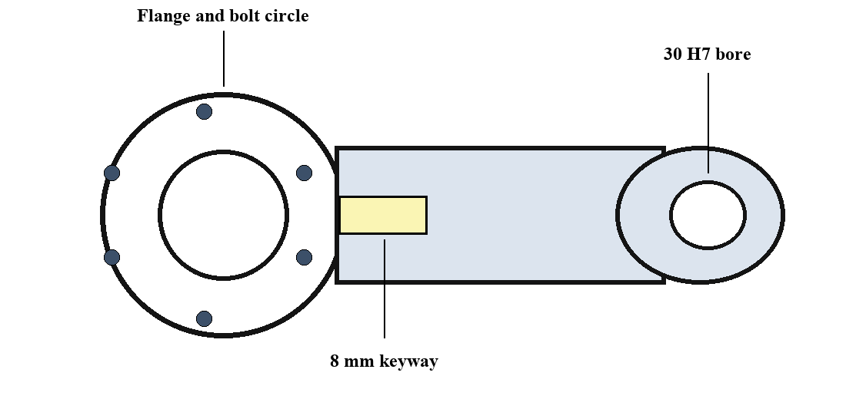
The component also illustrates why material allowance and machining order matter. The starting steel bar must be large enough to permit facing and turning, but it should not contain excessive material that increases cutting time and tool wear. Rough turning removes the majority of stock, while finish turning and boring create the accuracy and surface finish required for assembly. The keyway and holes are made after the bore is complete, because the finished bore gives a more reliable location than an unfinished external surface.
The engineering sketch below identifies the principal features used throughout the process plan. It is intentionally simplified; the approved production drawing would contain the final dimensions, tolerances, surface-finish symbols and material condition. The sketch helps the reader understand why the route begins with turning and boring, then uses the bore to locate the part for secondary machining and inspection.

2. Background
2.1 Functional Requirements and Manufacturing Risks
The hub has to satisfy both dimensional and functional requirements. The representative design uses a 30 H7 through bore, an 84 mm flange outside diameter, a 56 mm hub outside diameter, an 8 mm wide keyway and six M8 threaded holes on a 68 mm pitch circle diameter. The bore tolerance controls the shaft fit, while the relationship between the bore and outer diameters controls the rotating accuracy. The keyway must have the correct width and depth so that it transmits torque without excessive backlash or stress concentration.
The most important manufacturing risk is concentricity error. If the bore is machined after the outside diameter in a separate, poorly located chucking, the two axes can differ. A hub with this error may appear acceptable when individual dimensions are checked, yet it can run out when assembled on a shaft. The process plan controls this risk by machining the flange face, turned diameters and finished bore in a single lathe set-up. The part is not removed between these operations, so the bore and diameters share the same spindle axis.
A second risk is incorrect location of the keyway or bolt circle. The keyway should be positioned from the shaft axis, not from an external surface that may vary because of stock or turning allowance. The bolt-circle holes must be equally spaced and concentric with the bore so that the flange bolts enter without forcing the joint. The process plan therefore uses an expanding mandrel through the finished bore for vertical-machining-centre operations. The flange face provides axial seating while the bore provides radial location.
A third risk is poor edge condition. Drilling, tapping and milling create burrs that can interfere with assembly, damage seals or enter the bore. Burr control is not an optional cosmetic step. The process route includes chamfering, dedicated deburring, cleaning and visual inspection. These actions protect the functional surfaces and provide a part that can be handled safely by the next production or assembly operation.

2. Background
2.2 Production Assumptions and Planning Constraints
The case assumes normalized EN8/C45 medium-carbon steel supplied as 90 mm diameter round bar. This material is readily available, has adequate strength for many coupling applications and can be machined effectively with carbide turning inserts, high-speed-steel or carbide drilling tools, and suitable cutting fluid. The stock is cut to 95 mm length, providing an allowance for facing both ends before the final 78 mm length is achieved. Material identity is retained from receipt through packing by associating the bars and blanks with the batch number.
The planned annual demand is 12,000 components, released in batches of 250 parts. This assumption is important because it affects fixture selection and the amount of set-up time that can be justified. A simple three-jaw chuck may be acceptable for initial turning, but soft jaws or a purpose-made chucking arrangement improve repeatability in production. For secondary work, an expanding mandrel is selected because it locates on the finished bore and allows the keyway and bolt-circle features to be machined with one reliable fixture arrangement.
The workshop is assumed to have an automatic band saw, a CNC lathe, a vertical machining centre, a deburring station and standard inspection equipment. Available measuring instruments include vernier calipers, outside micrometers, a dial bore gauge, a dial indicator, a depth micrometer, thread plug gauges and, where available, a coordinate measuring machine. The route uses this equipment without requiring specialised processes such as grinding, since the bore tolerance and surface finish can be achieved through controlled boring and reaming for the representative design.
Planning constraints include machine capacity, tool life, operator skill, batch traceability and expected delivery time. The plan must avoid scheduling an operation on a machine that cannot hold the required accuracy. It must also identify inspection early enough to prevent a full batch of defective parts. These constraints are considered in the next sections when the objectives, datum strategy, machining sequence and control plan are developed.

3. Objectives
3.1 Technical Objectives of the Process Plan
The first objective is to establish a manufacturing route that follows the natural sequence of material removal. The blank is cut first, rough turning removes major stock, finish turning and boring establish precision geometry, and secondary milling and drilling complete non-rotational features. This sequence prevents finish surfaces from being damaged by heavy machining and reduces the chance that later operations will change the location of a critical feature. It also gives the operator a clear order of work and supports stable cycle-time planning.
The second objective is to create and maintain functional datums. Datum A is the finished flange face, which controls axial location in the coupling. Datum B is the finished bore axis, which controls radial location on the shaft. The plan requires the lathe to make these datums before the keyway and bolt circle. When the hub moves to the vertical machining centre, the expanding mandrel locates from Datum B and the fixture shoulder supports Datum A. This approach maintains the dimensional relationship that matters during assembly.
The third objective is to specify machines, tools and fixtures that are practical for batch manufacture. The planner selects a band saw for blanks, a CNC lathe for rotational features, and a vertical machining centre for the keyway and holes. It also identifies roughing inserts, finishing inserts, a boring bar, a reamer, an 8 mm end mill, drills, taps and gauges. Tooling details are important because an unsuitable cutting tool can create taper, poor surface finish, oversize holes or an unacceptable cycle time.
The fourth objective is to incorporate safety and material protection into the route. Sharp edges are broken after machining, chips are removed from the bore and threads, and finished components are washed before inspection. Protective oil and suitable packing prevent corrosion and surface damage during storage or transport. A good process plan therefore considers not only how the feature is machined, but also how the part remains acceptable until it reaches the customer or assembly line.

3. Objectives
3.2 Quality, Productivity and Traceability Objectives
The principal quality objective is to achieve the drawing requirements consistently. For this case, the bore must meet 30 H7, bore-to-outside-diameter runout should not exceed 0.03 mm, and the keyway and bolt circle must be positioned from the bore axis. Threaded holes are verified with a plug gauge and the flange surface is checked for damage. These controls are selected because they address the features most likely to affect fit, alignment and torque transfer in the completed coupling.
Productivity is also an objective because quality cannot be achieved at an impractical production cost. The plan reduces avoidable handling by combining related features in the same set-up. Rough turning, finish turning and bore finishing occur in one lathe cycle. Keyway milling, drilling and tapping occur after the part is placed on the mandrel, avoiding repeated relocation. The expected direct machining and handling time can then be measured during the first batch and used for realistic capacity planning, labour allocation and delivery scheduling.
Traceability provides the evidence that the route has been followed. The material certificate is checked at receipt, each batch is identified during saw cutting, and first-off inspection records verify the set-up before production continues. In-process measurement records show whether the keyway, holes and bore remain within control. Final inspection records connect the accepted part or batch to the relevant material, machine and inspection information. This is particularly important when a customer query, rework decision or process improvement review occurs later.
The final objective is continual improvement. The route sheet should be treated as a controlled production document rather than an unchangeable description. If inspection identifies repeated variation, the planner can adjust tool offsets, revise cutting conditions, improve the fixture or add a more suitable gauge. By recording such changes and verifying their effect, the workshop gradually improves capability, reduces rejection and builds confidence that the same component can be manufactured reliably over time.

4. Methodology / Approach
4.1 Drawing Review and Datum Planning
The method begins with a systematic drawing review. The planner identifies the material, overall shape, dimensions, tolerances, surface-finish requirements, threads and functional relationships. Not every dimension needs the same manufacturing control. A general external surface may allow a wider tolerance, while the shaft bore, flange face, keyway and bolt circle demand closer attention. This classification enables the planner to spend inspection time where it has the greatest effect on performance and to avoid unnecessary precision on non-critical areas.
The next decision is selection of the datum system. A datum is a theoretical reference used to control the location or orientation of other features. In the hub, the finished flange face becomes Datum A and the finished bore axis becomes Datum B. These datums are functional because the hub is seated against a flange and mounted on a shaft. The process plan creates them in the lathe as early as possible and prevents later machining from using a less accurate reference, such as a saw-cut end or rough outside diameter.
Workholding is planned together with the datum strategy. During initial turning, the bar is held in a chuck with adequate grip length. The first face is cleaned, and the workpiece remains clamped while the outer diameters and bore are machined. For secondary machining, an expanding mandrel grips the finished bore from inside. The mandrel gives positive concentric location without damaging the outside diameter, while its shoulder supports the finished flange face. This makes the fixture repeatable and easy for the operator to load.
The datum plan is verified during first-off inspection. A dial indicator checks the relationship between the bore and outside diameter, while bore gauges and face measurements confirm the functional features. If the readings are not satisfactory, the operator adjusts the machining offset, jaw condition, tool setting or fixture seating before the batch continues. Establishing this feedback loop at the start prevents an incorrect reference condition from affecting every part in the batch.

4. Methodology / Approach
4.2 Route Selection and Operation Sequencing
After the datums are defined, the planner selects the route sequence. Incoming inspection confirms that the steel grade and bar diameter are correct. Saw cutting prepares blanks with enough allowance for facing. The first CNC-lathe cycle faces the material, rough turns the external profile and drills a pilot hole. The same set-up then finish turns the flange and hub diameters, finishes the overall length, and bores or reams the 30 H7 through bore. The finished bore is protected from scratches when the part is transferred to the next machine.
The vertical machining centre is chosen for the non-rotational features because it can position the component accurately on the expanding mandrel. The keyway is milled with an 8 mm end mill. Its width and depth are checked with suitable gauges. The program then indexes the six bolt-circle locations, spot drills each position, drills the tap size and cuts the M8 thread. The drilling and tapping sequence is planned after the keyway so that the feature most directly related to torque transmission is completed and checked before the remaining holes are produced.
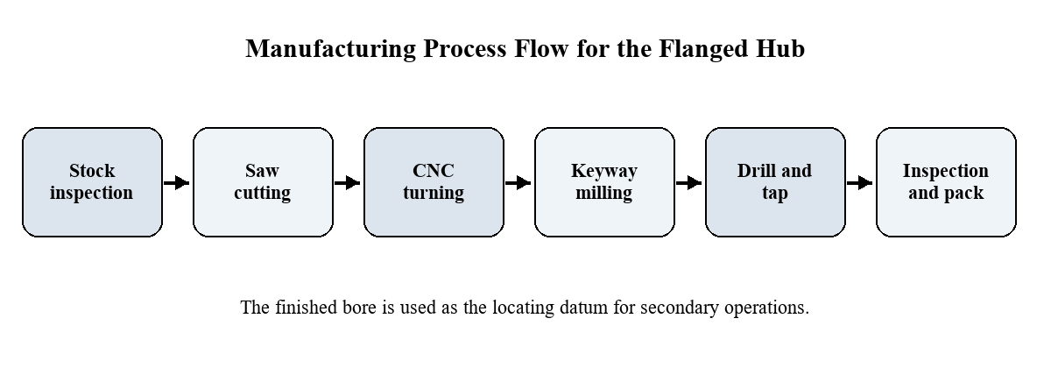
Deburring, cleaning and inspection follow machining. Burrs are removed from all sharp edges, especially the bore entry, keyway corners and threaded holes. Chips are cleaned from the part so that measurements are not affected and the coupling assembly is not contaminated. The final inspection checks the critical dimensions and verifies the visual condition. Accepted parts receive protective oil and packing material before transfer to the next operation or finished-goods store.
The flow diagram summarises this route. Its purpose is to show that the process is not merely a list of machines. Each stage prepares a stable and appropriate reference for the next one. By establishing the functional bore before milling and drilling, the route controls the relationship between features that will be assembled together. This is the central principle of the selected approach.

4. Methodology / Approach
4.3 Cutting Conditions, Documentation and Control Plan
A complete method also includes cutting conditions and work instructions. Rough turning uses a robust carbide insert and a feed that removes stock efficiently without overloading the machine or causing excessive vibration. Finish turning uses a suitable insert geometry and lower feed to obtain the required surface condition. Boring conditions are selected to minimise taper and chatter, while reaming conditions are controlled to avoid an oversize bore. The final values are determined from the material condition, tool manufacturer guidance, machine rigidity and trial results.
Tool life must be considered because gradual wear changes the size and finish of machined features. A dull turning insert can cause poor surface finish or diameter variation; a worn drill can oversize a hole; and a worn tap can damage threads. The route sheet therefore records tool identity and replacement criteria. For higher-volume production, the workshop may use tool-life counters or planned replacement intervals. Such controls reduce unexpected stoppages and prevent worn tools from producing a sequence of nonconforming components.
The route sheet lists the operation number, machine, fixture, tool, datum, work instruction and inspection method. This documentation gives the operator a clear standard and gives the supervisor a basis for planning. It also records special handling requirements, such as protecting the finished bore and removing burrs. The inspection plan identifies the measurement instrument, frequency and acceptance criterion for each critical feature. First-off verification is followed by interval sampling during the batch and final release inspection.
The methodology is reviewed after each production run. Actual cycle time, scrap, rework, tool consumption and inspection results are compared with the plan. If a problem is detected, the planner considers whether it is caused by material variation, machine condition, workholding, tool selection, programming or operator method. Corrective action is documented and re-verified. This feedback process turns the initial route plan into a continuously improved manufacturing standard.

5. Implementation
5.1 Material Preparation and CNC Turning Operations
Implementation begins at stores, where the EN8/C45 bar is checked against the purchase record and material certificate. The operator verifies the bar diameter, straightness, surface condition and heat or batch identification. Material that is corroded, significantly bent or not supported by the required certificate is segregated. Approved bars are loaded into the band saw and cut to 95 mm blank length. This allowance permits both ends to be faced while still achieving the required 78 mm finished length.
The blank is loaded into the CNC lathe with adequate chuck grip and supported as necessary for rigidity. The first operation faces the exposed end to remove the saw surface and create a clean reference. Rough turning then removes the major stock from the flange and hub diameters. A pilot drill opens the centre, reducing the load on the boring bar. Chips are controlled with appropriate cutting fluid and chip-breaking inserts so that the work area remains safe and the bore is not scratched during machining.
In the finish stage, the lathe uses the same chucking condition to complete the flange face, the hub diameter, the flange diameter, chamfers, overall length and finished bore. The boring bar creates geometry and the reamer, if specified, establishes the 30 H7 fit and surface finish. Because the outer diameters and bore are completed in one set-up, their axes share the same spindle reference. The operator measures the first-off component with micrometers, a bore gauge and a dial indicator before beginning the remaining batch.
Any deviation found during first-off inspection is corrected at this stage. For example, a bore close to the upper limit may require a reamer adjustment or revised boring allowance. Runout may require checking chuck jaws, tool pressure or workpiece seating. Only after the first-off part has been approved are subsequent blanks processed. This disciplined release prevents a small set-up error from creating a large quantity of rework or scrap.

5. Implementation
5.2 Secondary Machining, Deburring and Inspection
After turning, the component is transferred carefully to the vertical machining centre. The finished bore is cleaned and mounted on an expanding mandrel. The mandrel expands evenly inside the bore, establishing the bore axis as the fixture axis. The finished flange face seats against the fixture shoulder, controlling the axial position. This arrangement is superior to locating on the rough outer diameter because it references the surfaces that are functionally important in the final assembly.
The 8 mm keyway is milled first. The cutter is aligned with the programmed datum and moved to the specified depth. The operator checks keyway width with a gauge or calibrated measuring method and checks depth with a depth micrometer. Correct keyway geometry is important because it affects contact between the shaft, key and hub. Too narrow a keyway prevents assembly; too wide a keyway may allow movement and local loading; and excessive depth weakens the hub wall.
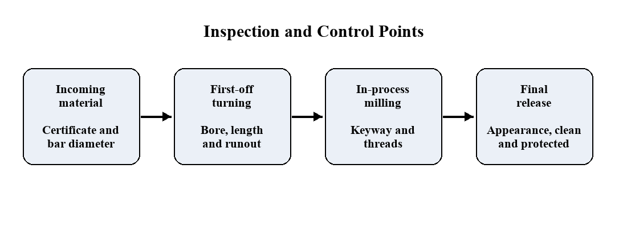
The bolt-circle holes are then spot drilled, drilled to tap size and tapped M8 at six equally spaced locations on the 68 mm pitch circle. Spot drilling prevents drill wander, while controlled tapping prevents damaged threads. A thread plug gauge confirms the thread quality. The bolt-circle position can be checked using a measuring fixture or coordinate measuring machine when required. The fixture and program are verified during the first-off check to ensure that the hole pattern is concentric with the finished bore.
The inspection sequence below shows how controls are distributed through the route. Material is checked before cutting, turning is verified on the first-off part, secondary features are sampled during machining and the final component is inspected before packing. This staged approach prevents defects from being hidden by later operations and allows quick corrective action at the point where a variation is introduced.

5. Implementation
5.3 Batch Control, Packing and Production Records
Batch control begins with clear identification. Each saw-cut blank or container of blanks is marked with the batch number and operation status. The route card moves with the batch, showing which operation has been completed, who performed it and whether first-off approval has been obtained. This prevents an unfinished component from being mixed with a finished component and allows supervisors to determine the exact stage of any work-in-progress quantity.
In-process inspection is planned at suitable intervals. A common approach is to measure critical features on the first component, then at intervals such as every 25 parts or after a tool change. The inspection frequency can be increased when a feature is close to a tolerance limit or when a new operator begins work. Measurements are recorded rather than remembered, allowing trends such as gradual bore growth or keyway-width drift to be identified before a nonconforming part is made.
Final release includes dimensional checks, visual examination, cleaning and corrosion protection. The inspector confirms that the bore, keyway, threads and flange faces are clean and free from burrs. The part is then coated with an approved rust preventive and packed using material that prevents contact damage. If components are transported, the packing should prevent the flanges from rubbing together and should keep dust or moisture out of the precision bore.
Production records support both quality assurance and future improvement. The batch record links the material certificate, CNC program revision, tool details, inspection readings and final quantity. If an assembly problem or customer complaint occurs, these records make it possible to investigate the manufacturing history. If the batch performs well, the same records provide evidence that the process conditions are capable and can be repeated on the next production order.

6. Conclusion and Future Scope
6.1 Conclusion
The detailed process plan demonstrates how a component design is converted into a controlled manufacturing route. The flanged hub requires several machining processes, but they are arranged around the functional relationship between the flange face, bore, keyway and bolt circle. The route starts with suitable bar stock, establishes functional datums in the lathe, uses the finished bore for secondary-machine location and includes inspection at every stage where a significant error could be introduced.
The most important decision is completion of the flange face, external diameters and bore in the same CNC-lathe set-up. This protects concentricity and ensures that the shaft fit and rotating surfaces are related to the same axis. The expanding mandrel then transfers this relationship to the vertical machining centre, allowing the keyway and bolt holes to be located from the functional bore. This datum-based approach is more reliable than using general external surfaces or repeatedly re-clamping the workpiece without a defined reference.
Quality is built into the route rather than added only at final inspection. Incoming material verification confirms that the correct stock is used. First-off inspection verifies the set-up before the batch continues. In-process sampling detects drift caused by tooling, machine condition or fixture seating. Final inspection, cleaning and corrosion protection confirm that the accepted component is suitable for assembly and storage. These controls reduce the risk of passing defects to the next operation.
The route also supports productivity by reducing unnecessary set-ups and combining compatible operations. Standard tools, fixtures and inspection methods make the plan understandable to the operator and repeatable for the supervisor. The result is a practical process plan that can be used as the foundation for production scheduling, cost estimation, operator instructions and continuous process improvement.

6. Conclusion and Future Scope
6.2 Future Scope and Improvement Opportunities
The first opportunity for improvement is to replace the representative cutting times in this report with measured production data. A time study can identify loading time, cutting time, tool-change time, inspection time and delay time for each operation. This information allows the planner to calculate realistic batch capacity, estimate cost and identify the operation that limits throughput. It also provides a baseline for assessing whether future automation or fixture investment is justified.
For higher volumes, bar-fed CNC turning can reduce blank-handling time and increase spindle utilisation. Automated part transfer between the lathe and machining centre can further reduce operator handling. A dedicated hydraulic or pneumatic fixture may replace the manual expanding mandrel when the batch size and production frequency are high enough to justify the investment. These improvements should be evaluated not only for speed but also for their ability to maintain datum control and reduce variation.
In-machine probing and statistical process control offer further quality improvements. A probe can measure selected features during machining and apply controlled offsets before the part leaves the machine. Statistical control charts for bore size, runout, keyway width and bolt-circle position can show whether the process is stable, drifting or affected by a special cause. When the process capability is demonstrated, the workshop may reduce unnecessary inspection while retaining confidence in the output.
Finally, the route sheet can be digitised and connected to material records, CNC programs, tool-life data and inspection results. Such a system supports traceability, faster revision control and better production reporting. The same planning principles can be applied to other machined components such as pulleys, couplings, bearing housings and shaft adaptors. The essential lesson remains the same: select functional datums early, control the sequence of operations and verify the features that determine assembly performance.

